- \Operation\Gluing\Gluing (page 1 of 2)
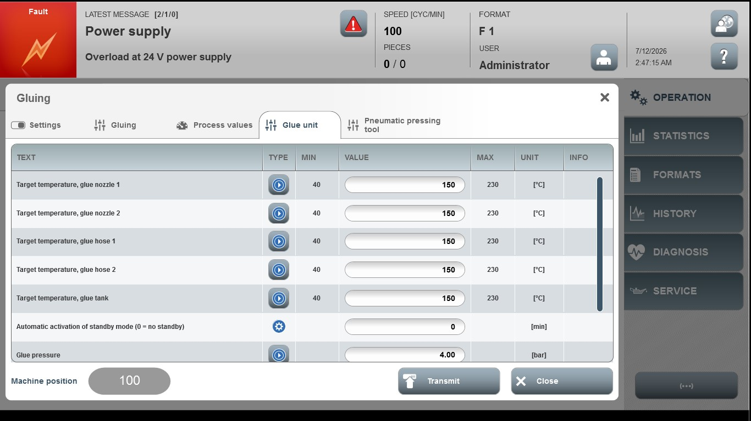
Acceptance criterion | Limits | Pass / Fail: Dev-No. | Date | Initials
Screen matches screenshot | N / A
Target temperature, glue nozzle 1 | 40…230
Target temperature, glue nozzle 2 | 40…230
Target temperature, glue hose 1 | 40…230
Target temperature, glue hose 2 | 40…230
Target temperature, glue tank | 40…230

- \Operation\Gluing\Gluing (page 2 of 2)
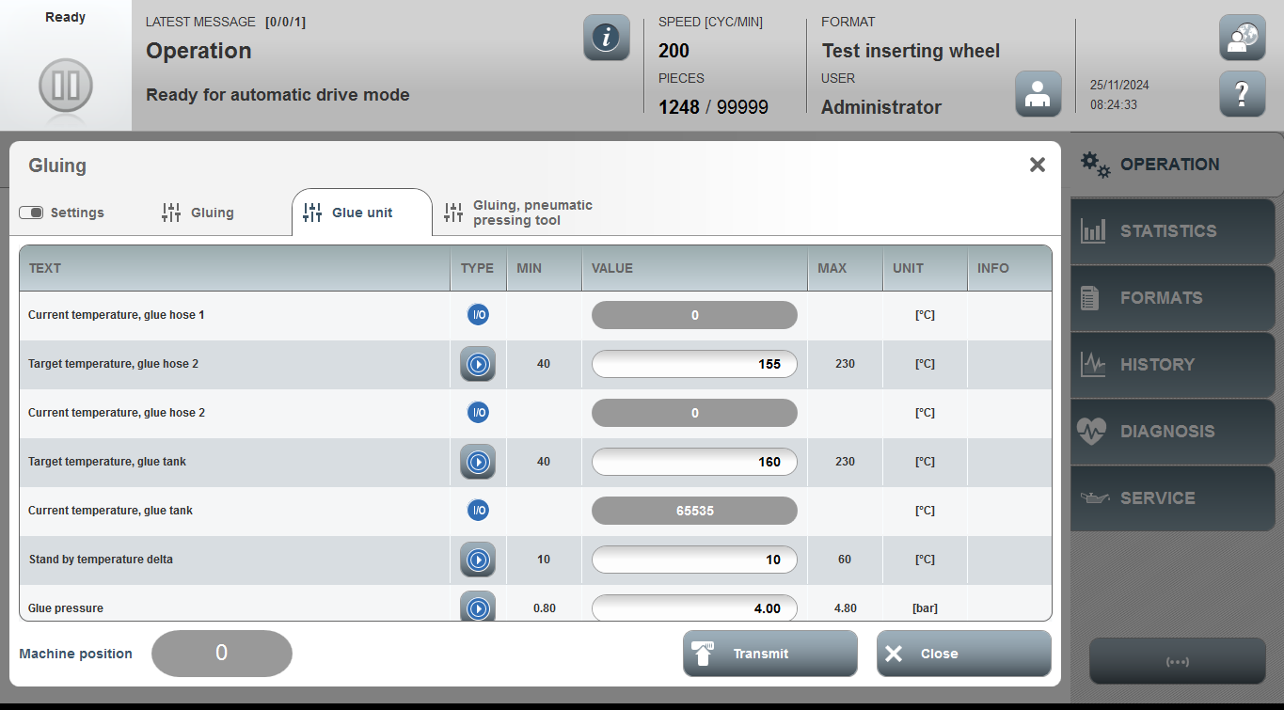
Acceptance criterion | Limits | Pass / Fail: Dev-No. | Date | Initials
Screen matches screenshot | N / A
Stand by temperature delta | 10…60
Glue pressure | 0.80…4.80

